**Introduction of the Pi Power & 4WD HAT**

**Table**

1. Overview 2

2. Appearance 2

2.1 2D image 2

2.2 Physical pictures 3

2.3 Appearance dimensions 4

3. Resource Introduction 4

4. Interface Definition 7

5. Specification 8

5.1 DRV8833 Specification 8

6. Saftey and notes 8

7. Introduction to Use 9

7.1 Power supply 9

7.2 Pin Description 9

7.3 DC motor interface 10

8. Make your suggestion and get support 13

# Overview

Cokoino Pi Power & 4WD HAT is a Raspberry Pi power and motor driver board suitable for Raspberry Pi 4B/3B/3B+/3A+/2B/1B+/1A+/Pi Zero/Pi Zero W. It is equipped with a PWM voltage management IC GS2678, which can support up to 7-12V input, rated output voltage of 5.1V, and maximum output current of 4A. It can support Raspberry Pi to work without the adapter. Simply connect a 7-12V battery pack to the board, which is more convenient for Raspberry Pi use.

At the same time, it is equipped with two Dual-H Bridge Current Control Motor Driver DRV8833 onboard, which can independently control the speed and steering of four DC motors at the same time. Therefore, it is more recommended for use on 4WD cars developed for Raspberry Pi.

# **Appearance**

## 2.1 2D image

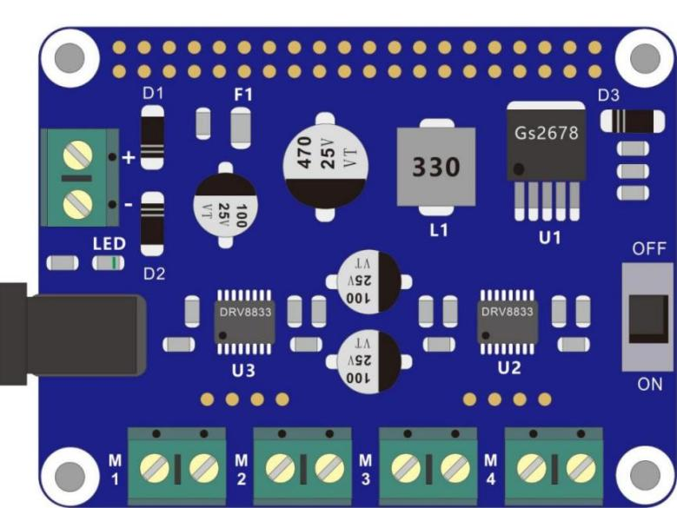

## 

## 2.2 Physical pictures

Top

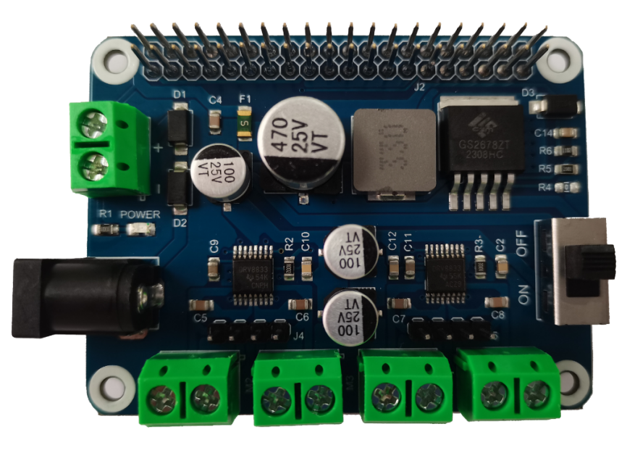

Bottom

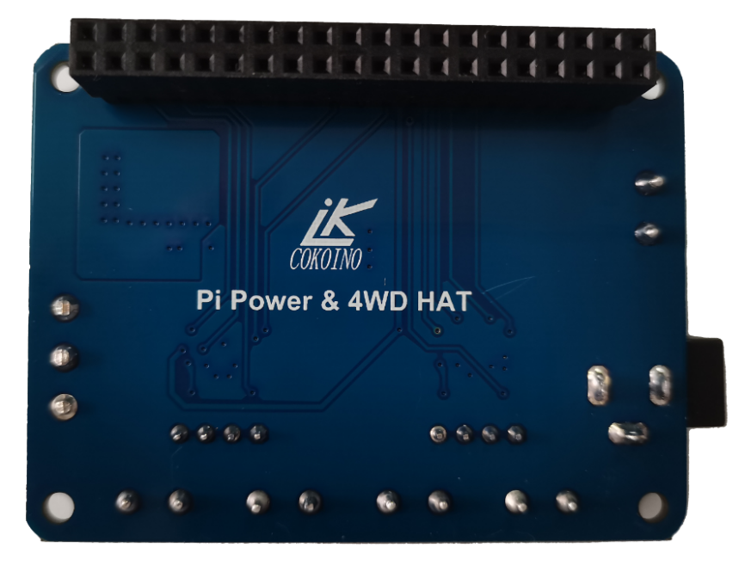

## 2.3 Appearance dimensions

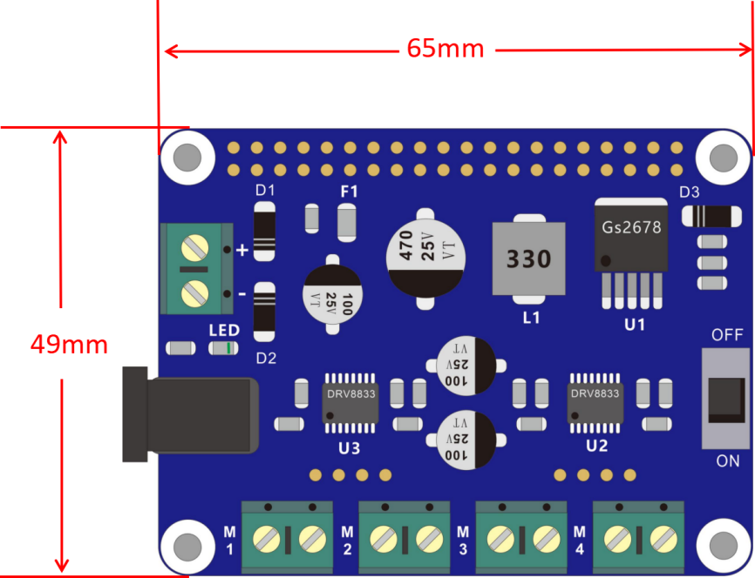

# 3. Resource Introduction

The Cokoino Pi Power&4WD HAT is suitable for Raspberry Pi 4B/3B/3B+/3A+/2B/1B+/1A+/Pi Zero/Pi Zero W, using a plastic long needle double row female. The row female corresponds to the insertion of Raspberry Pi, and the long needle corresponds to the signal of each pin of Raspberry Pi.

For the main components and functions of the Robot Control Board, please refer to the following table.

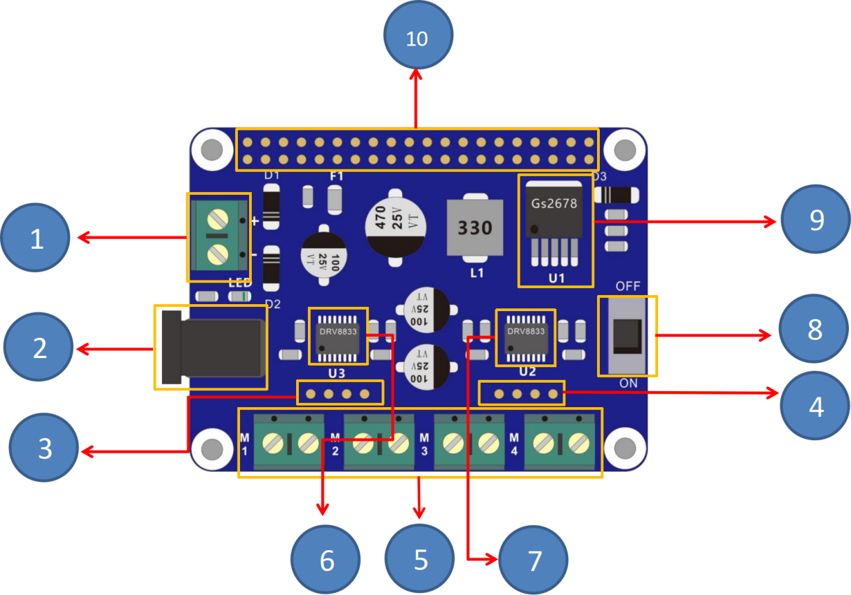

|  |  |  |
| --- | --- | --- |
| **No.** | **Component** | **Function** |
| 1 | Power port(terminal) | Power input 2pin port，pay attention to the positive and negative when connecting the external power supply, power supply range: 7-9V DC |
| 2 | Power port(DC port) | Power input DC port, power supply range: 7-9V DC |
| 3 | Motor interface (row pin) | 2.54 * 4 pin row pin, corresponding to circuit M1, M2 motor interface |
| 4 | Motor interface (row pin) | 2.54 * 4 pin row pin, corresponding to circuit M3, M4 motor interface |
| 5 | Motor interface (terminal) | KF301 two pin terminals, corresponding to circuit M1, M2, M3, M4 motor interface |
| 6 | DRV8833 | It is motor driver chip that can drive two DC Motors |
| 7 | DRV8833 | It is motor driver chip that can drive two DC Motors |
| 8 | Power Switch | Turn to ON to power on, turn to OFF to power off |
| 9 | GS2678 | GS2678 is an asynchronous DC buck converter with PWM voltage management IC and pulse width modulation output (PWM). The input voltage range can be from a minimum of 3.6V to a maximum of 32V, the output voltage can be adjusted from 0.8V-23V, and the output current can reach up to 5A |
| 10 | RaspberryPi interface | Plastic long needle double row female, the row female is connected to the row pin interface of the Raspberry Pi, and the long needle is used to expand the pins of the Raspberry Pi to the top of the Cokoino Pi Power&4WD HAT |

# 

# 4. Interface Definition

Pi Power&4WD HAT has 40 pins,pin distribution relative to Raspberry Pi

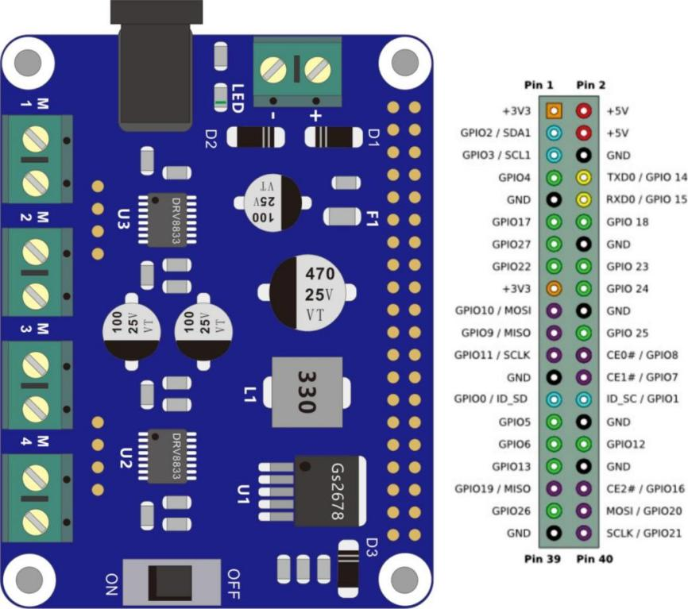

Taking Raspberry Pi 4B as an example, plug Pi Power&4WD HAT onto Raspberry Pi 4B as shown in the following figure.

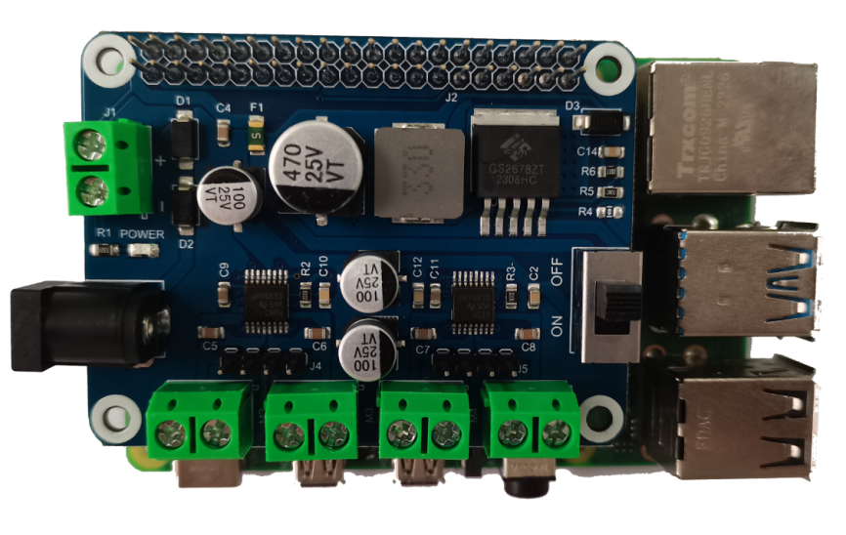

# Specification

## DRV8833 Specification

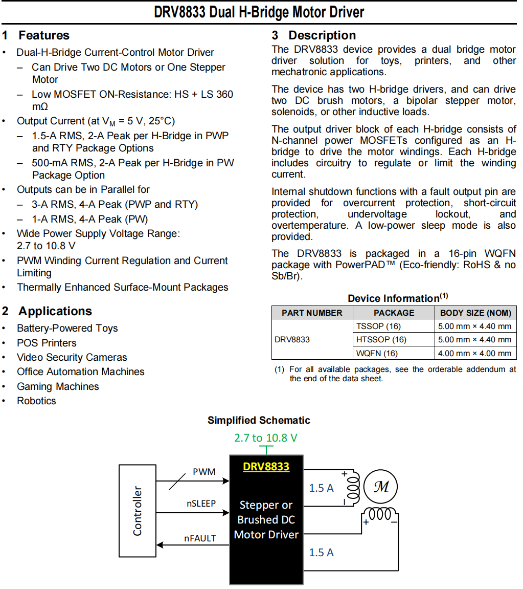

# Saftey and notes

The maximum output current of Pi Power&4WD HAT is 4A. Please do not use it to drive high-power motors. If the power of the entire circuit is too high and the current exceeds 4A, the F1 fuse on the board will blow.

Before using Pi Power&4WD HAT, Raspberry Pi, and some other modules to build a circuit, be sure to check if there are any problems with the circuit connection, especially if there is a short circuit between 3.3V and GND, and if there is a short circuit between 5V and GND? If powered on in a short circuit state, it may cause damage to some components on Pi Power&4WD HAT and Raspberry Pi, thus preventing them from working properly.

# Introduction to Use

## Power supply

The Pi Power&4WD HAT board provides two power supply ports, one is a DC socket sub interface and the other is a 2-pin terminal. Any power supply port connected to a 7-12V battery or adapter can support the operation of the board, and can be matched with different types of batteries (such as AA batteries, 18650 batteries), battery packs, or adapters, making it convenient for users to use.

Taking the 18650 battery as an example, use a battery box to power the Pi Power & 4WD HAT as shown in the following figure:

18650 battery box connected to 2-pin terminal for power supply

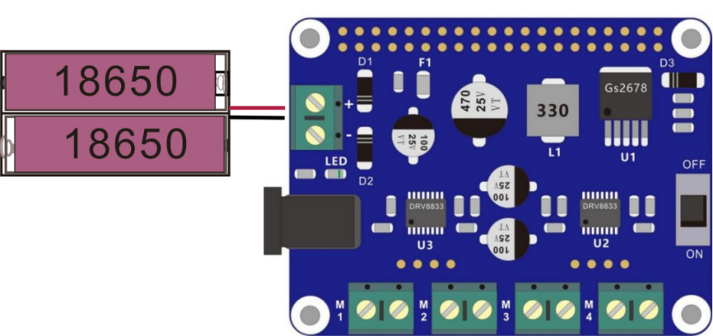

18650 battery box connected to DC socket for power supply

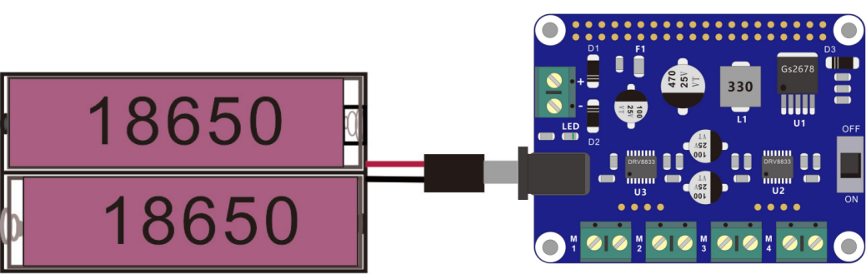

## Pin Description

The 40 pins on the Pi Power&4WD HAT board correspond one-to-one to the 40 pins on the Raspberry Pi. Therefore, after inserting the Pi Power&4WD HAT onto the Raspberry Pi, the Raspberry Pi signal can be extended and used on the Pi Power&4WD HAT. It should be noted that Pi Power&4W HAT has already occupied some signal pins for driving the motor chip DRV8833

**Pi Power&4W HAT occupy the pins of Raspberry Pi as shown in the table below**

|  |  |
| --- | --- |
| Pi Power & 4W HAT | Raspberry Pin |
| DRV8833#1 NSLEEP | GPIO12 |
| DRV8833#1 AIN1 | GPIO17 |
| DRV8833#1 AIN2 | GPIO27 |
| DRV8833#1 BIN1 | GPIO22 |
| DRV8833#1 BIN2 | GPIO23 |
|  |  |
| DRV8833#2 NSLEEP | GPIO13 |
| DRV8833#2 AIN1 | GPIO24 |
| DRV8833#2 AIN2 | GPIO25 |
| DRV8833#2 BIN1 | GPIO26 |
| DRV8833#2 BIN2 | GPIO16 |

## DC motor interface

The Pi Power&4WD HAT board supports driving 4 DC motors and is distributed with two types of motor interfaces, one is a 2-pin terminal interface and the other is a pin interface. The 2-pin terminal interface is marked as follows:

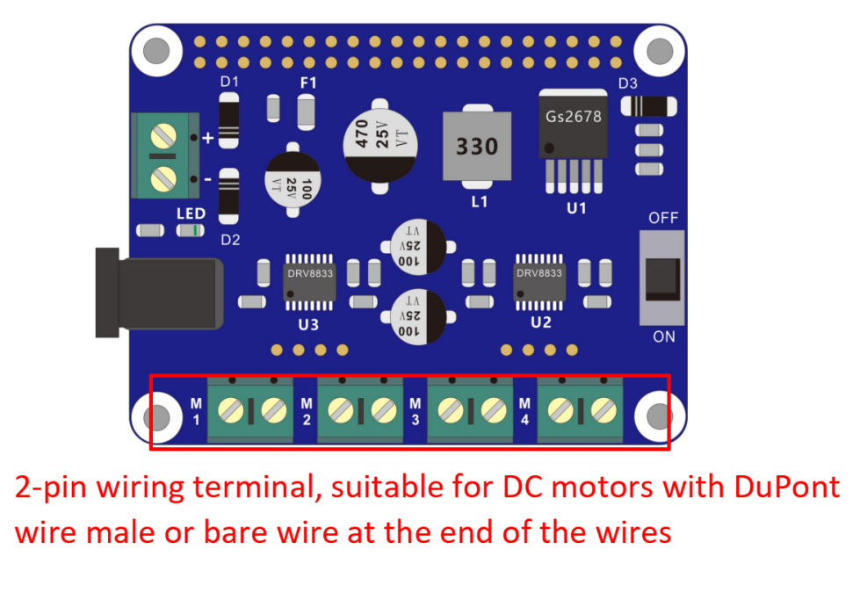

Taking TT motor as an example, as shown in the diagram below, the interface of Pi Power &4WD HAT connect motors which the wire end are DuPont wire male or bare wire .

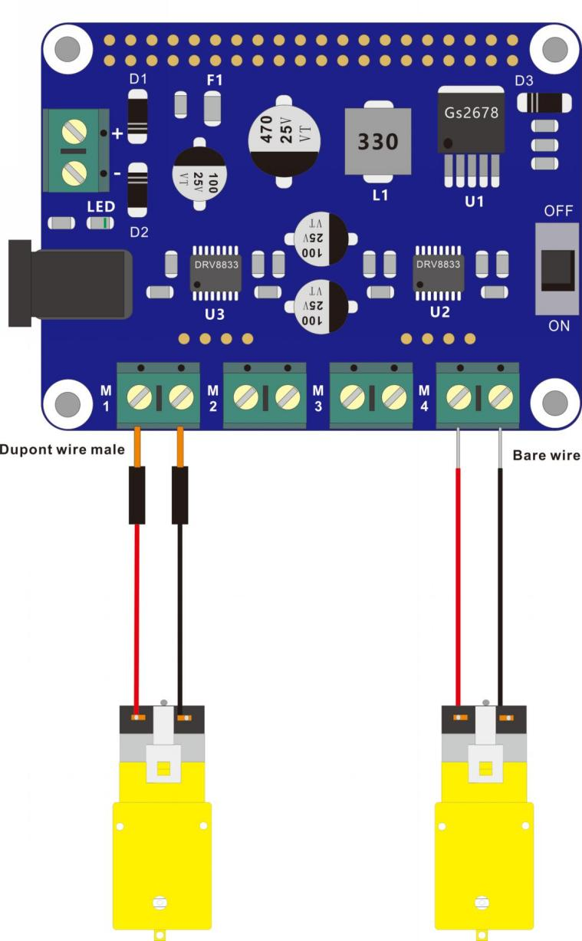

Another type of motor interface is row pin, suitable for connect the motors which end of the connection wire are DuPont female connectors.

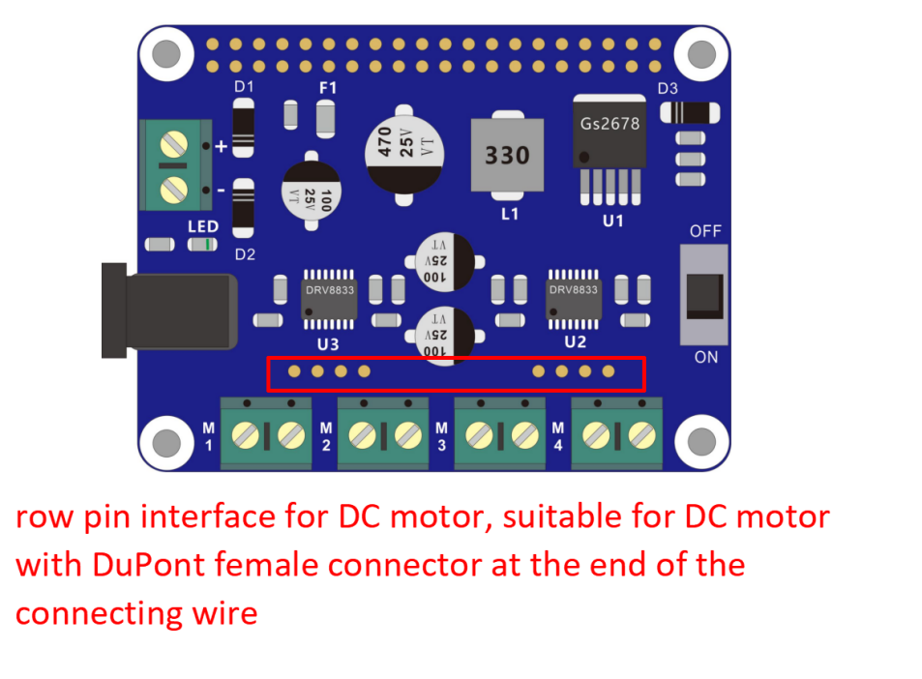

Taking TT motor as an example, as shown in the figure below, Pi Power&4WD HAT row pin interface connect the TT motor which the end of connecting wire are DuPont female connector.

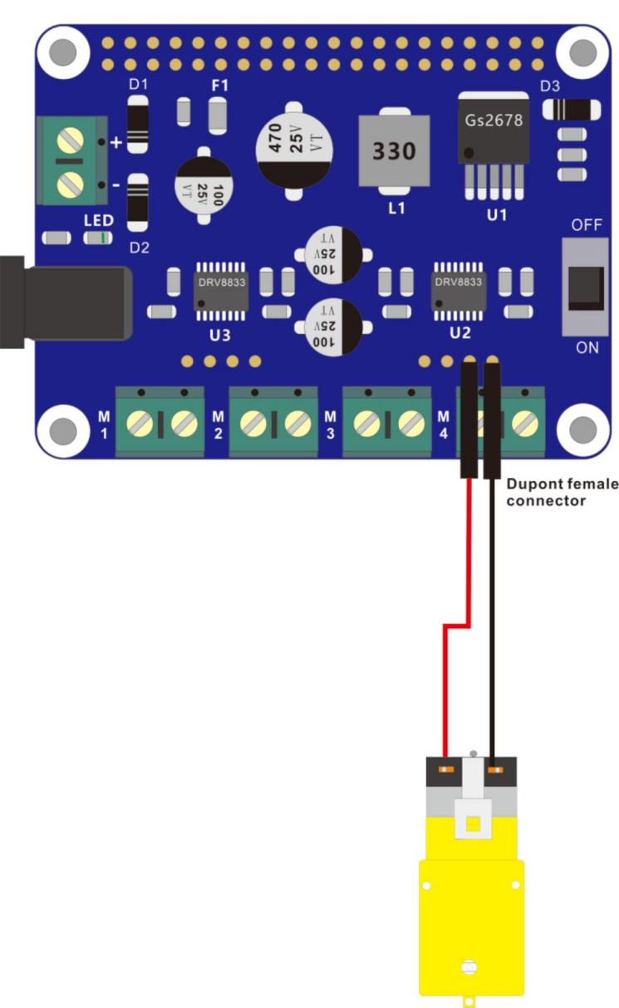

The motor serial number corresponding to the row pin interface is shown in the following figure

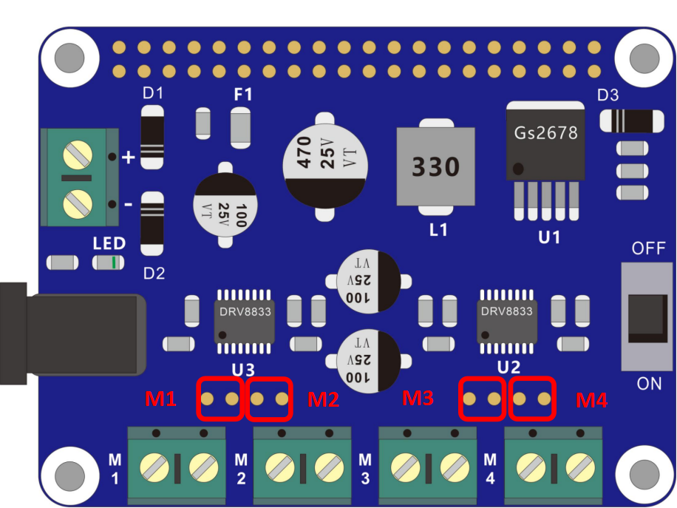

# Make your suggestion and get support

THANK YOU for reading this document!

If you find any errors, omissions or you have suggestions and/or questions about this document, please feel free to contact us: **[cokoino@outlook.com](mailto:cokoino@outlook.com)**

We will make every effort to make changes and correct errors as soon as feasibly possible and publish a revised version.

If you want to learn more about Arduino, Raspberry Pi, Smart Cars, Robotics and other interesting products in science and technology, please continue to visit our Amazon Store by search for "LK COKOINO" on Amazon. We will continue to launch fun, cost-effective, innovative and exciting products.

Thank you again for choosing Cokoino products.

**LK COKOINO**